Hkkjr ekSle foKku foHkkx |  | India Meteorological Department
Hkkjr ekSle lkjka’k |  | DAILY WEATHER SUMMARY
Sunday, 3rd April 2022 (13th Chaitra 1944 Saka)
Summary of observations recorded at 0830 hours IST: The trough/wind discontinuity from Telangana to interior Tamil Nadu ran from Marathwada to north interior Tamil Nadu across interior Karnataka and extended upto 0.9 km above m. s. l. The western disturbance as a trough in mid tropospheric levels with its axis at 5.8 km above m. s. l. ran roughly along Long.70°E and to the north of Lat.32°N. The cyclonic circulation over west Rajasthan and adjoining central Pakistan which extended upto 1.5 km above m. s. l. persisted. A trough in westerlies between 1.5 km and 3.1 km above m. s. l. ran roughly along Long.89°E to the north of Lat.20°N. Above three systems are likely to move east-northeastward. A cyclonic circulation lay over southeast Madhya Pradesh and neighbourhood, which extended upto 1.5 km above m. s. l. A cyclonic circulation lay over south Tamil Nadu and neighbourhood, which extended upto 1.5 km above m. s. l. An upper air cyclonic circulation is likely to form over south Andaman sea and neighbourhood on 06th April. Under its influence, a low pressure area is likely to form over southeast Bay of Bengal during subsequent 24 hours. The cyclonic circulation over Jharkhand and neighbourhood which extended upto 0.9 km above m. s. l. became less marked. The trough from east Bihar to north Odisha at 1.5 km above m. s. l. became less marked. The cyclonic circulation over northeast Bangladesh and neighbourhood which extended upto 0.9 km above m. s. l. became less marked.
Heat Wave to Severe Heat Wave conditions were observed in most pockets of west Rajasthan and in isolated pockets of Himachal Pradesh, Delhi and heat wave conditions in isolated pockets of east Rajasthan and Jharkhand.
Day temperatures were markedly above normal (5.1°C or more) at most places over Jammu-Kashmir-Ladakh-Gilgit-Baltistan-Muzaffarabad, Himachal Pradesh, Punjab, Haryana, Chandigarh, Delhi, west Rajasthan and at a few places over Uttarakhand, east Rajasthan and Jharkhand; appreciably above normal (3.1°C to 5.0°C) at many places over Uttar Pradesh, Madhya Pradesh and Vidarbha; at a few places over Saurashtra, Kutch, Madhya Maharashtra, Marathwada and Chhattisgarh; at many places over Gujarat Region; at a few places over Konkan, Goa and Odisha and at isolated places over Telangana, Kerala and Mahe. They were markedly below normal (-5.1°C or less) at a few places over Assam, Meghalaya and Sub-Himalayan West Bengal and Sikkim; appreciably below normal (-3.1°C to -5.0°C) at isolated places over Gangetic West Bengal and Bihar; below normal (-1.6°C to -3.0°C) at a few places over Arunachal Pradesh, Lakshadweep and near normal over rest parts of the country. Yesterday, the highest maximum temperature of 43.6°C was reported at Barmer (West Rajasthan) over the country.
Thunderstorm observed (from 0830 hours IST of yesterday-0830 hours IST of today): at isolated places over Assam, Meghalaya, Sub-Himalayan West Bengal, Sikkim, Coastal Karnataka and Kerala-Mahe.

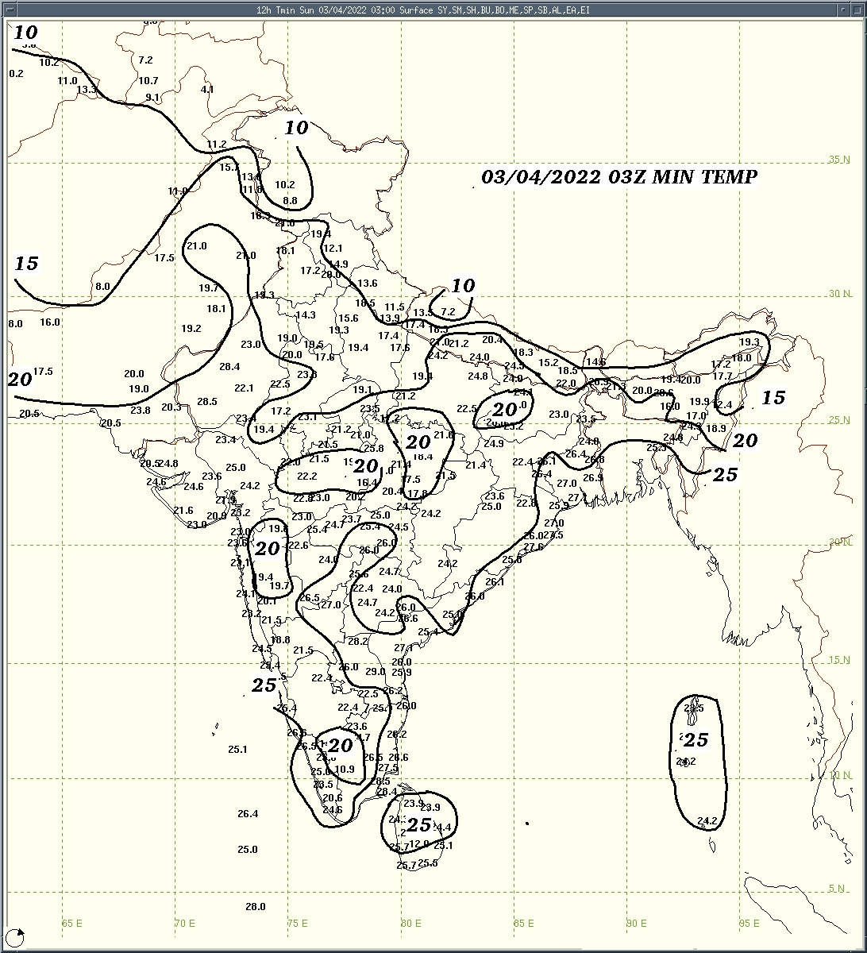 | 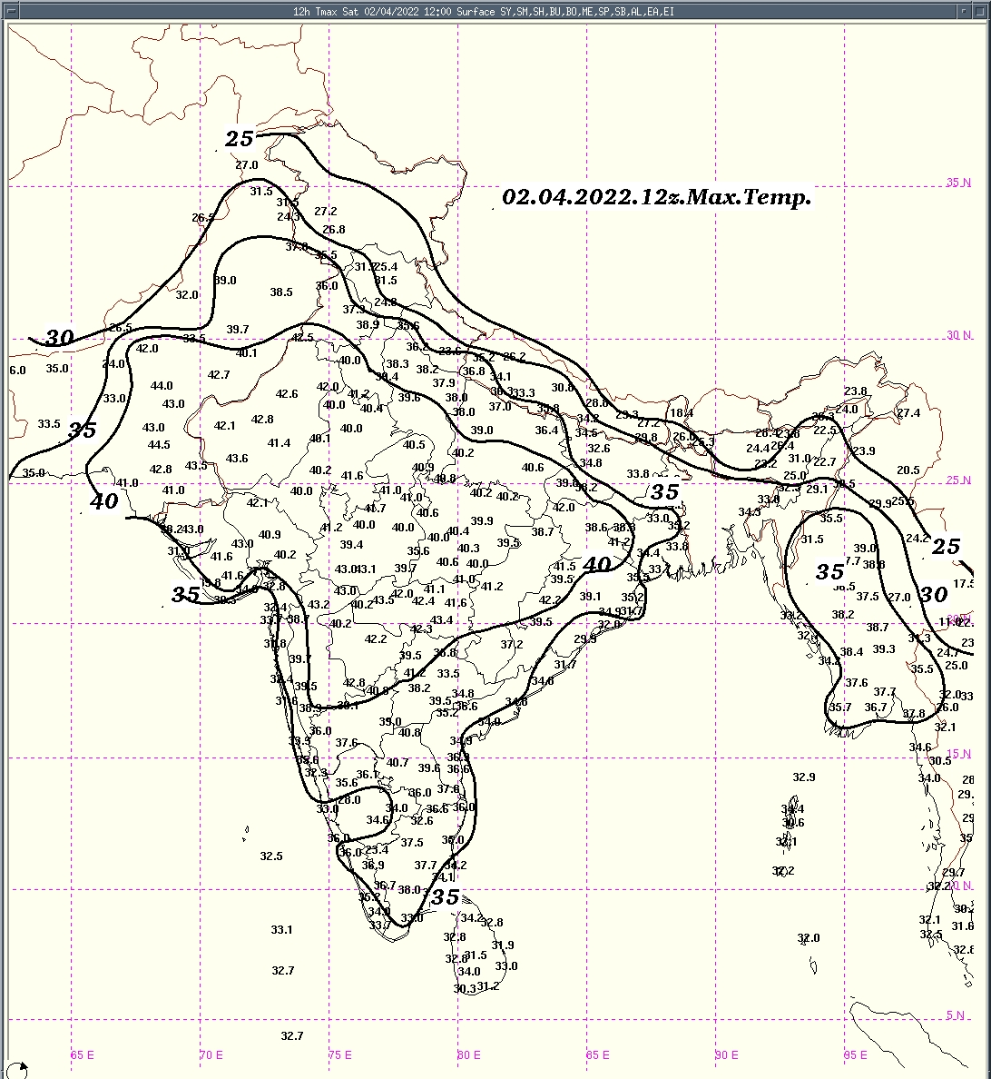 | 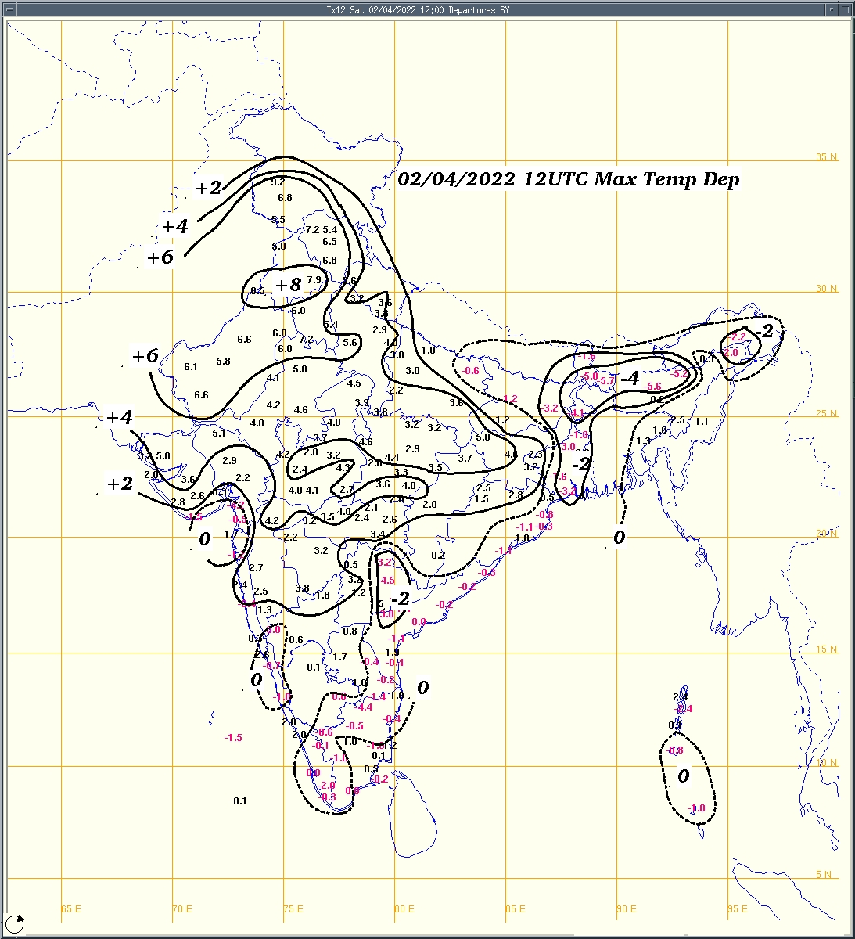
Fig.1a: Minimum temperature (⁰C) | Fig.2a: Maximum temperature (⁰C) | Fig.2b: Maximum temperature departure(⁰C)
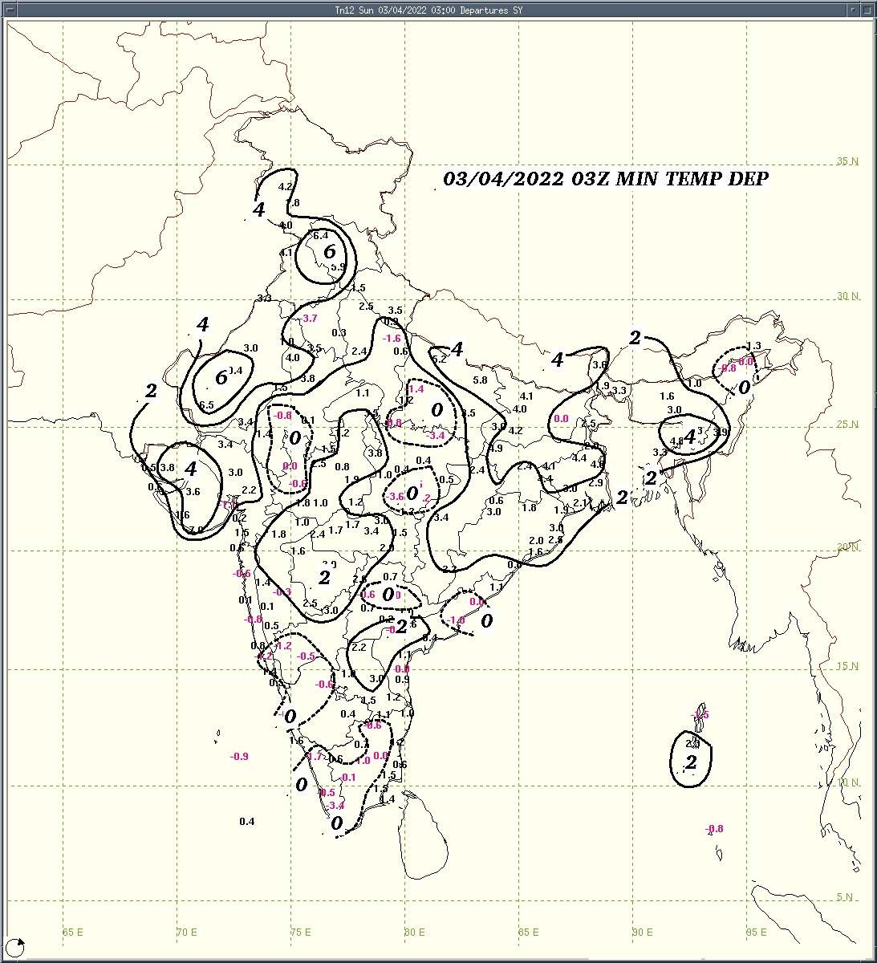  Fig.1b:Minimum temperature departure (⁰C) | 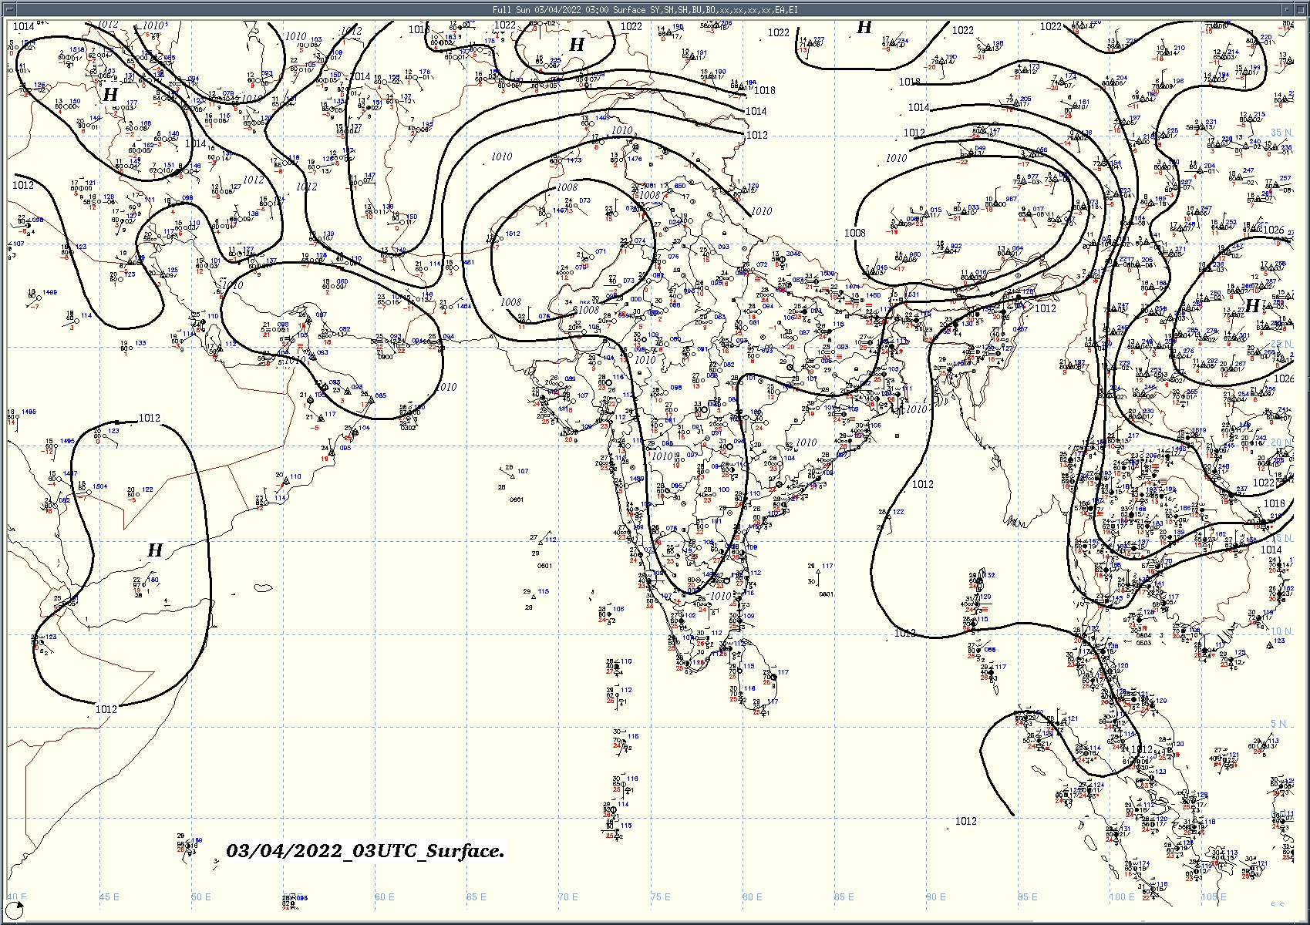  Fig.3: Analysed surface chart based on 03z observation
Dr. Anupam Kashyapi,
Scientist 'F'
CR&S Office, Pune  Issued at 1245 hrs. IST |  | Weather Forecasting Division

Indian Regions | Table 1. Realised rainfall (chief amount in cm during past 24 hrs)
East | most places: Arunachal Pradesh and Sub-Himalayan West Bengal & Sikkim  a few places: Assam & Meghalaya⁺  isolated places: Nagaland-Manipur-Mizoram-Tripura◆, Odisha and Bihar  dry weather: Gangetic West Bengal and Jharkhand  Gossaigaon 8.8, Cooch behar 5.9, Singhik 5.6, Sankalan 5.5, Kokrajhar 4.5, Roing 3.7, Tuting 3.4, Thakurganj & Kishanganj 1.7 each, Pasighat Aero 1.6, Dhubri IMD 1.2, Similiguda & Forbesganj 0.5 each, Mangkolemba & Mokokchang 0.2 each.
North | dry weather: Uttar Pradesh, Uttarakhand, Haryana, Punjab, Himachal Pradesh, Jammu-Kashmir and Ladakh and Rajasthan
Central | dry weather: Madhya Pradesh, Vidarbha and Chhattisgarh
Peninsula | a few places: Kerala  isolated places: Telangana, Rayalaseema◆, Tamil Nadu⁺ and coastal and south interior Karnataka  dry weather: Gujarat Region, Saurashtra & Kutch, Konkan & Goa, Madhya Maharashtra, Marathwada, coastal Andhra Pradesh and north interior Karnataka  Devakottai 7.6, Ambasamudram 5.9, Konni ARG 4.9, Sringeri hms 4.8, Kanjirappally 4.7, Kottayam 2.6, Belthangadi 1.9, Chikkamagaluru pto 1.8, Subramanya & Hassan 1.3 each, Thanjavur pto 0.9, Kollapur(arg) & Panambur obsy 0.5 each, Alur 0.1.
Islands | a few places: Andaman & Nicobar  dry weather: Lakshadweep  Car Nicobar 1.8, Nancowary 0.8, Hut bay 0.2.
Table 2. Forecast / warnings (distribution of rain / thundershowers) for 5 days (valid from time of origin upto 0830 hrs IST of next day)
Sr. No. | Sub-division Name | Day 1 | Day 2 | Day 3 | Day 4 | Day 5 | Sr. No. | Sub-division Name | Day 1 | Day 2 | Day 3 | Day 4 | Day 5
 |  | 03 April | 04 April | 05 April | 06 April | 07 April |  |  | 03 April | 04 April | 05 April | 06 April | 07 April
1 | Andaman Nicobar Islands | F | F | W+ | W+ | W | 19 | west Madhya Pradesh | D+ | D+ | D+ | D | D
2 | Arunachal Pradesh | W++ | W++ | W+ | F | F | 20 | east Madhya Pradesh | D+ | D+ | D+ | D | D
3 | Assam-Meghalaya | W# | W# | F+ | S | S | 21 | Gujarat Region | D+ | D+ | D+ | D | D
4 | Nagaland-Manipur-Mizoram-Tripura | F+ | S | S | I | I | 22 | Saurashtra and Kutch | D+ | D+ | D+ | D | D
5 | Sub Himalayan West Bengal/Sikkim | W+ | W+ | W | W | F | 23 | Konkan and Goa | D | D | I | I | I
6 | Gangetic West Bengal | I | I | D | D | D | 24 | Madhya Maharashtra | D | D | I | I | I
7 | Odisha | I | I | I | D | D | 25 | Marathwada | D | D | D | D | D
8 | Jharkhand | D+ | D+ | D+ | D | D | 26 | Vidarbha | I | I | D | D | D
9 | Bihar | I | D | D | D | D | 27 | Chhattisgarh | D | D | D | I | D
10 | east Uttar Pradesh | D+ | D+ | D+ | D+ | D+ | 28 | coastal Andhra Pradesh and Yanam | I | I | I | D | I
11 | west Uttar Pradesh | D+ | D+ | D+ | D+ | D+ | 29 | Telangana | D | D | D | D | I
12 | Uttarakhand | D | D | D | D | D | 30 | Rayalaseema | D | D | D | D | D
13 | Haryana, Chandigarh and Delhi | D+ | D+ | D+ | D+ | D+ | 31 | Tamil Nadu, Puducherry and Karaikal | I+ | I | I | I | I
14 | Punjab | D | D | D | D | D | 32 | coastal Karnataka | I | I | I | I | I
15 | Himachal Pradesh | D+ | D+ | D | D | D | 33 | north interior Karnataka | D | D | I | I | I
16 | Jammu-Kashmir and Ladakh | I + | D | D | D | D | 34 | south interior Karnataka | I | I | S | S | I
17 | west Rajasthan | D + | D+ | D+ | D+ | D+ | 35 | Kerala and Mahe | S | S | S | S | S
18 | east Rajasthan | D+ | D+ | D+ | D+ | D+ | 36 | Lakshadweep | S | D | D | D | D

Legends: D = Dry I = Isolated S = Scattered F = Fairly widespread W = Widespread #= heavy to very heavy rain at a few places with extreamly heavy rain at isolated places +++= heavy rain at a few places with very heavy rain at isolated places ++ = heavy to very heavy rainfall + = heavy rain ●/* = rain or snow ♦ = very light rain ≡ =fog = thunderstorm with lightning =Gusty wind / strong wind / gale wind -=cold wave/cold day +-= heat wave =Duststorm SS=ground frost = squall/Hail
Fig. 4: Districtwise warnings for five days for Maharashtra State
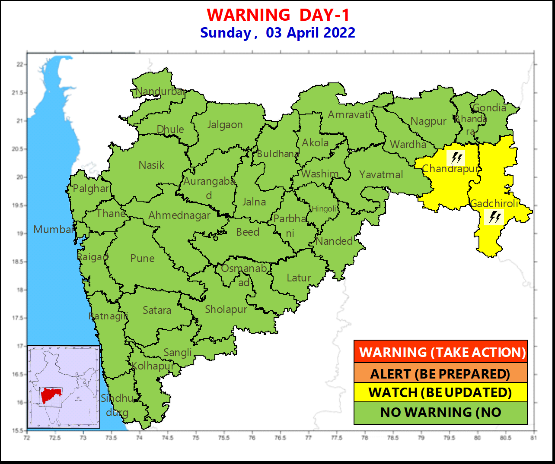

Pune, Lohegaon and Pashan observations at 0830 hrs. IST of Today
 | Temperature (°C) |  |  |  |  |  |  |  |  |  |  |  |  |  | Humidity (%) |  |  |  |  |  |  | Rainfall (mm)
 | Max.  past  24 hrs |  |  |  | Dep.  from  normal |  |  | Min.  past  24 hrs. |  | Dep.  from  normal |  | Dry  Bulb |  |  | At 0830 hrs. IST |  | Dep.  From  normal |  | At 1730  hrs. IST of y’day |  | Dep.  from  normal | Past  24 hrs. | Since  1st March | Dep.  from  normal
PNE | 39.7 |  |  |  | 2.6 |  |  | 19.4* |  | 1.5 |  | 26.6 |  |  | 62 |  | 12 |  | 27 |  | 5 | 0.0 | 1.2 | -2.4
PSN | 40.2 |  |  |  | - |  |  | 20.1* |  | - |  | 23.6 |  |  | 73 |  | - |  | 23 |  | - | 0.0 | 0.8 | -
LHG | 39.6 |  |  |  | 1.6 |  |  | 20.1* |  | 1.1 |  | 27.0 |  |  | 60 |  | 18 |  | 23 |  | 5 | 0.0 | 0.8 | -4.3
Local (Pune and neighbourhood) forecast
Max. / Min. Temperature (°C) |  |  |  |  |  |  |  |  |  |  |  |  |  | Weather
Date | Pune |  | Pashan |  |  | Lohegaon |  |  | Chinchwad |  | Lavale |  | Magarpatta
03/04 | 39 / 19.4* |  | 40 / 20.1* |  |  | 40 / 20.1* |  |  | 41 / 23.0* |  | 41 / 21.6* |  | 41 / 24.3* | Mainly clear sky.
04/04 | 40 / 20 |  | 40 / 20 |  |  | 40 / 21 |  |  | 41 / 23 |  | 41 / 22 |  | 41/ 25 | Mainly clear sky becoming partly cloudy sky towards afternoon / evening .
05/04 | 39 / 20 |  | 40 / 21 |  |  | 39 / 21 |  |  | 41 / 24 |  | 40 / 23 |  | 40 / 25 | Mainly clear sky becoming partly cloudy sky towards afternoon / evening.
06/04 | 39 / 21 |  | 39 / 22 |  |  | 39 / 22 |  |  | 40 / 24 |  | 40 / 23 |  | 39 / 25 | Mainly clear sky becoming partly cloudy sky towards afternoon / evening.
07/04 | 39 / 21 |  | 39 / 22 |  |  | 39 / 23 |  |  | 40 / 24 |  | 40 / 23 |  | 39 / 25 | Mainly clear sky becoming partly cloudy sky towards afternoon / evening.
08/04 | 38 / 22 |  | 38 / 23 |  |  | 38 / 23 |  |  | 39 / 25 |  | 39 / 24 |  | 39 / 26 | Partly cloudy sky.
09/04 | 38 / 23 |  | 37 / 24 |  |  | 37 / 24 |  |  | 39 / 25 |  | 38 / 25 |  | 38 / 26 | Partly cloudy sky.
Mumbai (Colaba) |  |  |  |  |  |  |  |  |  |  |  |  |  |  |  | Nagpur (AP)
Date |  | Tmax °C |  | Tmin °C |  |  | Weather |  |  |  |  |  |  |  |  | Tmax °C |  | Tmin °C |  | Weather
03/04 |  | 33 |  | 23 |  |  | Mainly clear sky. |  |  |  |  |  |  |  |  | 41 |  | 25 |  | Mainly clear sky.
04/04 |  | 33 |  | 23 |  |  | Mainly clear sky. |  |  |  |  |  |  |  |  | 41 |  | 25 |  | Mainly clear sky.
05/04 |  | 33 |  | 24 |  |  | Mainly clear sky becoming partly cloudy sky towards afternoon / evening. |  |  |  |  |  |  |  |  | 41 |  | 25 |  | Mainly clear sky.
06/04 |  | 34 |  | 25 |  |  | Generally cloudy sky. |  |  |  |  |  |  |  |  | 40 |  | 25 |  | Mainly clear sky.
07/04 |  | 33 |  | 25 |  |  | Partly cloudy sky. |  |  |  |  |  |  |  |  | 40 |  | 25 |  | Partly cloudy sky
08/04 |  | 32 |  | 25 |  |  | Partly cloudy sky. |  |  |  |  |  |  |  |  | 40 |  | 26 |  | Partly cloudy sky .
08/04 |  | 32 |  | 24 |  |  | Partly cloudy sky. |  |  |  |  |  |  |  |  | 40 |  | 26 |  | Partly cloudy sky .

Widespread (W) | 76 - 100 |  |  |  |  | - Rainfall | Very light rain | trace to 2.4
Fairly widespread (F) | 51 - 75 |  |  |  |  |  | Light rain | 2.5 to 15.5
Scattered (S) | 26 - 50 |  |  |  |  |  | Moderate rain | 15.6 to 64.4
Isolated (I) | 1 - 25 |  |  |  |  |  | Heavy rain | 64.5 to 115.5
Dry (D) | No Rain |  |  |  |  |  | Very heavy rain | 115.6 to 204.4
Probability Terms in %: |  |  |  |  |  |  | Extremely heavy rain | ≥ 204.5
unlikely | < 25 |  |  |  |  | - Snowfall | Heavy snow | 6.5 to 11.5 cms water equivalent of rain
likely | between 25, 50 |  |  |  |  |  | Very heavy snow | 11.6 to 20.4 cms water equivalent of rain
very likely | between 51, 75
most likely | >75

